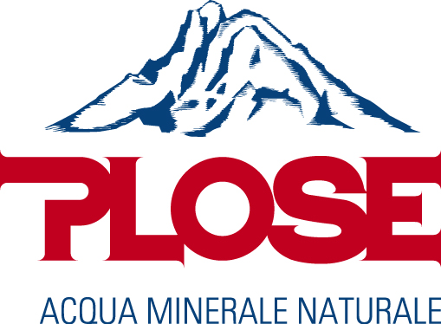

Barilla Pasta World Championship, September 27-28, Milan, September 29-Parma
FONTE PLOSE ALWAYS SUPPORTING THE BARILLA ACADEMY TO PROMOTE THE GOOD KITCHEN IN ITALY AND ALL OVER THE WORLD.
LIGHT AND EXTREMELY PURE, ACQUA PLOSE WATER SUPPORTS THE FAMOUS BARILLA CHALLENGE EXALTING THE TASTE OF THE CREATIONS PREPARE BY CHEF COMING FROM THE BEST RESTAURANTS ABROAD
September 27, 2017, Milan - The 6th Barilla Pasta World Championship opens today, one of the most expected events among those organized by Barilla with the advice of Academia Barilla, a challenge that each year compares the most talented international chefs in the world, called to prepare their best pasta dishes, judged by a quality jury and starred chef.
Fonte Plose, partner of the Culinary Institute Academia Barilla since its founding in Parma in 2004, will participate of course as technical sponsor. Fonte Plose, a long lasting family company and an example of Italian excellence in the beverage field, in fact has been always supporting the Academia Barilla project sharing with it the cultural approach to gastronomy, the contribution to the preservation of raw materials and their territories of origin, the valorisation of good cuisine in Italy and all over the world.
Plose supports Academia Barilla's goals as a technical sponsor in all its initiatives, and at the celebrated Barilla Pasta World Championship Acqua Plose will accompany the young chefs in their race, the judges and the audience, celebrating pasta as an icon of the Italian cuisine, combining good taste, well-being, conviviality, simplicity but also versatility in the kitchen. Pure and light from high mountain, Acqua Plose Water has all the ideal features to match gourmet dishes while exalting flavors and ingredients.
Involved in the pleasure of contributing to the event and the promotion of the Italian talent to combine taste, quality and creativity, the two sponsors Fonte Plose and Lavazza have created a collaboration ad hoc for this event. At the Lavazza corner, guests could try an original "Espresso Tonic" for which the Lavazza Training Center will use the Plose Vintage Tonica, a classic among the Plose Vintage soft drinks, prepared according to an old recipe without chemical dyes and bottled exclusively in glass bottles to preserve their qualities. Plose will also provide Lavazza with all the purity and lightness of its Water to enhance the aroma of the proposed coffees.

Plose Water. Pure, light, gourmet.
Born at 1870m, it reaches the best tables around the world.

The promotion of good food and healthy lifestyle is a commitment that Fonte Plose, a famous long-standing company from South Tyrol, brings to its daily activities, contributing to the growth of the image of quality and authenticity that have always distinguished Italy.
Fonte Plose preserves and makes available to consumers the exceptional features of Acqua Plose indeed, it is extremely pure because it flows from a 1,870 m source at the top of Mount Plose in South Tyrol, near the unspoilt nature of the Puez Natural Park in the Dolomites. Since the 1960s, Plose contributes to the preservation of the land, using sustainable productive processes and bottling water strictly in glass.
Such quality and reliability, appreciated by Academia Barilla, are also recognized by experienced foodies and chefs who every day bring Acqua Plose on the table to accompany their dishes.
With a fixed residue of only 22.0 mg/l and a very low hardness (1.2 F) is one of the purest and lightest water in the world, its pH value of 6.6 makes it ideal for being assimilated by the human body and, compared to the average water on the market, it has a very high oxygen content (about 10 mg/l). These properties make Acqua Plose soft and light on the palate, and therefore ideal to match and enhance the best dishes of the traditional Italian cuisine as well as the international one.
www.acquaplose.com

